**Finding needles in a haystack: determining key molecular descriptors associated with the blood-brain barrier entry of chemical compounds using machine learning**

Subhabrata Majumdara*, Subhash C. Basakb, Claudiu N. Lunguc, Mircea V. Diudeac and Gregory D. Grunwaldd

aUniversity of Florida Informatics Institute, 432 Newell Dr, CISE Bldg E251, Gainesville FL 32611, USA;   
bDepartment of Chemistry and Biochemistry, University of Minnesota, 246 Chemistry Building, 1039 University Drive, Duluth MN 55812, USA;  
cDepartment of Chemistry, Babes-Bolyai University, Strada Arany János 11, Cluj-Napoca 400028, Romania;  
dNatural Resources Research Institute, University of Minnesota, 5013 Miller Trunk Highway, Duluth MN 55811, USA.

*Currently at AT&T Labs Research. Correspondence e-mail: subho@research.att.com

Abstract:  
In this paper we used two sets of calculated molecular descriptors to predict blood-brain barrier (BBB) entry of a collection of 415 chemicals. First set of 579 descriptors were calculated by Schrodinger and TopoCluj software. Polly and Triplet software were used to calculate the second set of 198 descriptors. Random forest modelling and a two-deep, repeated external validation method was used for QSAR formulation. Results show that both sets of descriptors individually and their combination give models of reasonable prediction accuracy. We also uncover the effectiveness of a variable selection approach, by showing that for one of our descriptor sets, the top 5% predictors in terms of random forest variable importance are able to provide a better performing model than the model with all predictors. The top influential descriptors indicate important aspects of molecular structural features that govern BBB entry of chemicals.

Keywords: blood-brain barrier; molecular descriptors; variable selection; machine learning; random forest; two-deep cross validation; quantitative structure-activity relationship (QSAR)

**1. Introduction**

There is a lot of interest in the pharmacological, drug discovery, and computational chemistry literature in the prediction of blood-brain barrier (BBB) entry of molecules [1, 2, 3, 4, 5, 6, 7]. The BBB is an important barrier comprising endothelial cells and tight junctions between them which allow selective entry of solutes from the blood to the brain. The prospect of many promising psychoactive drug candidates will be diminished if they cannot cross the BBB to a desirable extent. Also, the drug designer would like to assure that drugs whose target is not the central nervous system do not cross the BBB to minimize undesirable side effects. Methods of rational drug design may produce many promising new drug entities, but they will not emerge as psychoactive drugs if they do not possess desirable BBB penetration profiles.

Various methods have been used before to assess the BBB permeability of chemicals. One quantifier of BBB entry is BB, which is the ratio of the concentration of a chemical in the brain to its concentration in the blood. Li *et al* [7] developed computational models to predict this quantity for a set of 415 chemicals using molecular descriptors. But these days we have the availability of expanded set of descriptors, more sophisticated modeling methods as well as more computational power. Therefore, it was of interest to develop Quantitative Structure-Activity Relationship (QSAR)-s for the BBB entry of the 415-chemical set using molecular descriptors calculated by POLLY, APProbe, Triplet, and TopoCluj software and applying quantitative modeling methods. For predictive modelling in the QSAR context, there is ample evidence that ‘black box’ type machine learning methods tend to perform better than conventional statistical techniques like logistic regression [8, 9]. Among such methods, we decided to use random forest as our method of choice because of its effectiveness in the QSAR context when a large number of descriptors are involved [9].

The present paper is organized as follows. In section 2 we give all details of our QSAR implementation: the data, descriptors, methods and validation techniques. Section 3 gives the results on our analysis, on which we elaborate upon in Section 4. We end the paper with concluding remarks in Section 5.

**2. Methods and materials**

***2.1. Data***

The data (Supplementary File S1) on the BBB activity of 415 chemical compounds is taken from [7]. The response variable is binary, and indicates whether a chemical is able to penetrate the BBB. We removed 3 compounds because of some descriptors not being calculated for them. Among the remaining chemicals, there are 275 compounds that are able to go through the BBB and 137 that are not able to. In the original paper, [7] use several statistical and machine learning methods to model this binary BBB activity based on 199 molecular descriptors, and applied a feature selection method, Recursive Feature Elimilation [10], to determine influential features.

***2.2. Molecular Descriptors***

We use two collections of molecular descriptors for our QSAR model building exercise. The first set of descriptors, calculated and utilized by the Cluj team of Diudea and collaborators, were calculated by the softwares Schrodinger [11] and TopoCluj [12]. Detailed references about these descriptors are given in the Supplementary table S2. We include 579 such descriptors in our analysis.

The second set of descriptors, used frequently by Basak et al [13, 14, 15, 16], is calculated using the softwares POLLY [17] and Triplet [18]. We use 98 and 100 descriptors calculated by these softwares, respectively. These descriptors are generally referred to as topological indices (TIs), since they are derived from graph theoretical methods. TIs include both topostructural (TS) and topochemical (TC) subclasses. The former encode information strictly on molecular connectivity. The later include chemical features in addition to topological information. These chemical features include atom and bond type. Table 1 provides a list of the TIs from the Basak lab used in this study, along with brief descriptions.

Table 1. Symbols and definitions of topological indices (TIs).

|  |  |
| --- | --- |
|  | Topostructural (TS) |
| *IWD* | Information index for the magnitudes of distances between all possible pairs of vertices of a graph |
| *IWD* | Mean information index for the magnitude of distance |
| *W* | Wiener index = half-sum of the off-diagonal elements of the distance matrix of a graph |
| *ID* | Degree complexity |
| *HV* | Graph vertex complexity |
| *HD* | Graph distance complexity |
| *IC* | Information content of the distance matrix partitioned by frequency of occurrences of distance *h* |
| *M1* | A Zagreb group parameter = sum of square of degree over all vertices |
| *M2* | A Zagreb group parameter = sum of cross-product of degrees over all neighboring (connected) vertices |
| *hχ* | Path connectivity index of order *h* = 0-6 |
| *hχC* | Cluster connectivity index of order *h* = 3-6 |
| *hχPC* | Path-cluster connectivity index of order *h* = 4-6 |
| *hχCh* | Chain connectivity index of order *h* = 3-6 |
| *Ph* | Number of paths of length *h* = 0-10 |
| DN2Sy | Triplet index from distance matrix, square of graph order, and distance sum; operation y = 1-5 |
| DN21y | Triplet index from distance matrix, square of graph order, and number 1; operation y = 1-5 |
| AS1y | Triplet index from adjacency matrix, distance sum, and number 1; operation y = 1-5 |
| DS1y | Triplet index from distance matrix, distance sum, and number 1; operation y = 1-5 |
| ASNy | Triplet index from adjacency matrix, distance sum, and graph order; operation y = 1-5 |
| DSNy | Triplet index from distance matrix, distance sum, and graph order; operation y = 1-5 |
| DN2Ny | Triplet index from distance matrix, square of graph order, and graph order; operation y = 1-5 |
| ANSy | Triplet index from adjacency matrix, graph order, and distance sum; operation y = 1-5 |
| AN1y | Triplet index from adjacency matrix, graph order, and number 1; operation y = 1-5 |
| ANNy | Triplet index from adjacency matrix, graph order, and graph order again; operation y = 1-5 |
| ASVy | Triplet index from adjacency matrix, distance sum, and vertex degree; operation y = 1-5 |
| DSVy | Triplet index from distance matrix, distance sum, and vertex degree; operation y = 1-5 |
| ANVy | Triplet index from adjacency matrix, graph order, and vertex degree; operation y = 1-5 |
| Topochemical (TC) | |
| O | Order of neighborhood when ICr reaches its maximum value for the hydrogen-filled graph |
| Oorb | Order of neighborhood when ICr reaches its maximum value for the hydrogen-suppressed graph |
| IORB | Information content or complexity of the hydrogen-suppressed graph at its maximum neighborhood of vertices |
| ICr | Mean information content or complexity of a graph based on the rth (r = 0-6) order neighborhood of vertices in a hydrogen-filled graph |
| SICr | Structural information content for rth (r = 0-6) order neighborhood of vertices in a hydrogen-filled graph |
| CICr | Complementary information content for rth (r = 0-6) order neighborhood of vertices in a hydrogen-filled graph |
| hχb | Bond path connectivity index of order h = 0-6 |
| hχbC | Bond cluster connectivity index of order h = 3-6 |
| hχbCh | Bond chain connectivity index of order h = 3- 6 |
| hχbPC | Bond path-cluster connectivity index of order h = 4-6 |
| hχv | Valence path connectivity index of order h = 0-6 |
| hχvC | Valence cluster connectivity index of order h = 3-6 |
| hχvCh | Valence chain connectivity index of order h = 3-6 |
| hχvPC | Valence path-cluster connectivity index of order h = 4-6 |
| AZVy | Triplet index from adjacency matrix, atomic number, and vertex degree; operation y = 1-5 |
| AZSy | Triplet index from adjacency matrix, atomic number, and distance sum; operation y = 1-5 |
| ASZy | Triplet index from adjacency matrix, distance sum, and atomic number; operation y = 1-5 |
| AZNy | Triplet index from adjacency matrix, atomic number, and graph order; operation y = 1-5 |
| ANZy | Triplet index from adjacency matrix, graph order, and atomic number; operation y = 1-5 |
| DSZy | Triplet index from distance matrix, distance sum, and atomic number; operation y = 1-5 |
| DN2Zy | Triplet index from distance matrix, square of graph order, and atomic number; operation  y = 1-5 |

***2.3. Modelling technique***

We use Random Forest (RF) to obtain our QSAR models. First introduced by [19], this method has become one of the main pillars of predictive modelling in the past two decades. Technically, the method considers multiple random subsets of the full feature-set, and trains a decision tree based on each of these truncated feature. To obtain predictions for a set of values of the full feature set, one prediction is obtained from each of the decision trees trained. For a regression problem, these tree-level features are averaged to obtain the final prediction. On the other hand, in classification problems, the aggregate predicted class is that predicted by a majority of the trees. RF models have previously been used in QSAR modelling in diverse scenarios [20, 21, 22]. For BBB modelling, the efficacy of machine learning models has been demonstrated previouslu by [7, 20]. For this reason, we choose random forests to obtain our QSAR predictive models.

Variable importance in RF models is calculated by the total amount of Gini impurity reduction caused by trees containing a specific variable (https://www.displayr.com/how-is-variable-importance-calculated-for-a-random-forest/). we use this as our measure of variable importance in the results section.

***2.4. Validation***

*2.4.1. Beware of (single-split) external validation!*

We use a multi-split cross-validation method to evaluate our QSAR models. For a small set of chemical compounds, external validation based on a single train-test split is unstable, and a leave-one-out (LOO) approach is preferable [21, 22]. Furthermore, since the training set is smaller than the full dataset, it gives a biased estimate of the unknown standard error [23]. On the other hand, the LOO cross-validation is prone to overfitting [24]. In our situation, even though we have a considerably large set of compounds, the model evaluation metrics vary considerably across different random splits of the data (see Supplementary table x). For this reason, we use a multi-split external validation to evaluate the performance of our models. This simply means repeating an external validation method 100 times over different random train-test splits of the data, and taking the average of any metrics obtained over all such splits. This is also known as Monte-Carlo Cross Validation (MCCV) [25], and provides stable estimates of evaluation metrics [22], avoids overfitted models [25], and provided that the number of splits considered is large, gives unbiased estimate of the generalization error, i.e. *q*2 [23].

*2.4.2. Two-deep cross validation*

In this study, we aim to compare predictions of random forest models based on the top *θ*% of predictors in terms of variable importance across a range of values for *θ*. Since the variable importance depends on the trained model, it changes based on training samples it is trained on, i.e. across different train-test splits of the data. For this reason, it is imperative that a separate all-descriptor model (referred to as full model from now on) is trained for each train-test split, and then perform retraining based on the top predictors from the trained model *for that specific split*. Even though training the full model based on all might intuitively look like a correct thing to do, this naïve approach would use information from holdout compounds in the training step, thus synthetically inflating all model metrics. The cross-validated *q*2: obtained from such practices has been coined as naïve *q*2 [26].

Since training a random forest model involves using cross-validation as well, we essentially perform cross-validation twice in our procedure: first time to train the full model inside each train-test split, and then to obtain model evaluation metrics. The steps of this two-stage cross validation procedure, called *Two-deep Cross Validation* [26, 27, 28, 22, 8], are as given below:

1. Split the data into training and test sets randomly.
2. Using samples in the training set, train a random forest model that uses all predictors.
3. Obtain variable importance for all descriptors. Select the top *θ*% descriptors, use them to train a new RF model, and obtain validation metrics by evaluating the new model on the test compounds. Repeat for all values of *θ* that are being considered.
4. Repeat steps (a)-(c) for the requisite number of train-test splits.

*2.4.3. Metrics*

We use the following performance metrics to compare predictive model outputs using the above validation technique.

*a) Area Under Curve (AUC)*: This is defined as the area covered under a Receiver Operating Characteric (ROC) curve that plots the precision and recall values obtained from setting different thresholds to a set of predicted probabilities obtained from a classification model. The maximum value of AUC is 1, denoting perfect separation of the two classes of the response variable. Thus, a larger value of AUC indicates a better predictive model.

*b) Top 20% lift*: Suppose the response has two levels in a classification problem: 0 and 1, and the model outputs predicted probabilities of a sample belonging to class 1. Then the Top 20% lift denotes the ratio of class 1 samples which are in the samples in the top 20% predicted probabilities, divided by the ratio of class 1 samples in the overall population. For a bad model, this ratio will be closer to 1, since that means the top 20% of prediction scores cover about the same proportion of class 1 as a random guess from the full population. Whereas in a good model most of class 1 samples will have a high score, and thus the top 20% scores are more likely to cover those samples.

**3. Results**

The results obtained from our analysis can be classified into two parts. Firstly we aim to find out the important variables in our developed QSAR models, and compare these variables across the two different predictor sets as well as the combined set of predictors. After this we use subsets of the top predictors for each methods (like top 5%, 10%, 15%, …), build new models with these variables, and compare their performance with the full models using different validation metrics. We used the statistical software R v3.3.2 [29] to do all our data analyses.

*Top descriptors in QSAR models*

Table 2 lists the top 10 descriptors in the full models built on the Basak, Diudea and combined set of descriptors, respectively.

Table 2. Most important descriptors for the three predictor sets.

|  |  |  |  |
| --- | --- | --- | --- |
| *Basak lab* | | | |
| Variable | Importance | Variable | Importance |
| IC1 | 2.23 | IC4 | 1.32 |
| IC2 | 1.90 | SIC3 | 1.27 |
| ANZ4 | 1.58 | AZN4 | 1.22 |
| SIC1 | 1.56 | ANZ5 | 1.21 |
| DN2N3 | 1.54 | SIC2 | 1.20 |
| *Diudea lab* | | | |
| Variable | Importance | Variable | Importance |
| PSA | 2.51 | PEOE1 | 1.83 |
| Sum.of.topological.distances.between.O..O | 2.35 | E.state | 1.66 |
| E.state.topological.parameter | 2.20 | Superpendentic | 1.49 |
| ALOGP3 | 2.06 | Topological.charge.index.of.order.5 | 1.31 |
| Sum.of.topological.distances.between.N..O | 1.99 | PEOE12 | 1.28 |
| *Combined* | | | |
| Variable | Importance | Variable | Importance |
| Sum.of.topological.distances.between.O..O | 2.30 | E.state | 1.31 |
| E.state.topological.parameter | 2.22 | Sum.of.topological.distances.between.N..O | 1.21 |
| PSA | 1.56 | Molecular.electrotopological.variation | 1.12 |
| Superpendentic | 1.44 | PEOE1 | 0.99 |
| ALOGP3 | 1.37 | PEOE12 | 0.87 |

*Validation*

We use a repeated external validation, also known as monte-carlo cross validation [28] in the literature, to evaluate the predictive performance of our QSAR models. To this end, we calculate each of the two metrics: AUC and top 20% lift for the full models for each descriptor set, as well as random forest models built from the top 5%, 10%, …, 90%, 95% of descriptors as per variable importance. Notice that in a two-deep validation setup, this means that for each train-test split, we take the descriptors that have the highest 5%, 10% etc. variable importances in the model obtained *using the training data of that specific split*.

We summarize our results in Table 3 and Figures 1.

|  |  |  |
| --- | --- | --- |
| *Full model* | | |
| Descriptor set | AUC | Top 20% lift |
| Basak lab | 0.82 (0.04) | 4.7 (0.23) |
| Diudea lab | 0.81 (0.05) | 4.69 (0.28) |
| Combined | 0.81 (0.04) | 4.72 (0.24) |
| *Best model* | | |
| Descriptor set | AUC | Top 20% lift |
| Basak lab | 0.82 (0.04) | 4.71 (0.23) |
| Diudea lab | 0.85 (0.04) | 4.81 (0.28) |
| Combined | 0.85 (0.04) | 4.86 (0.24) |

Table 3: Average and standard deviation (in brackets) of model metrics for the three descriptor sets

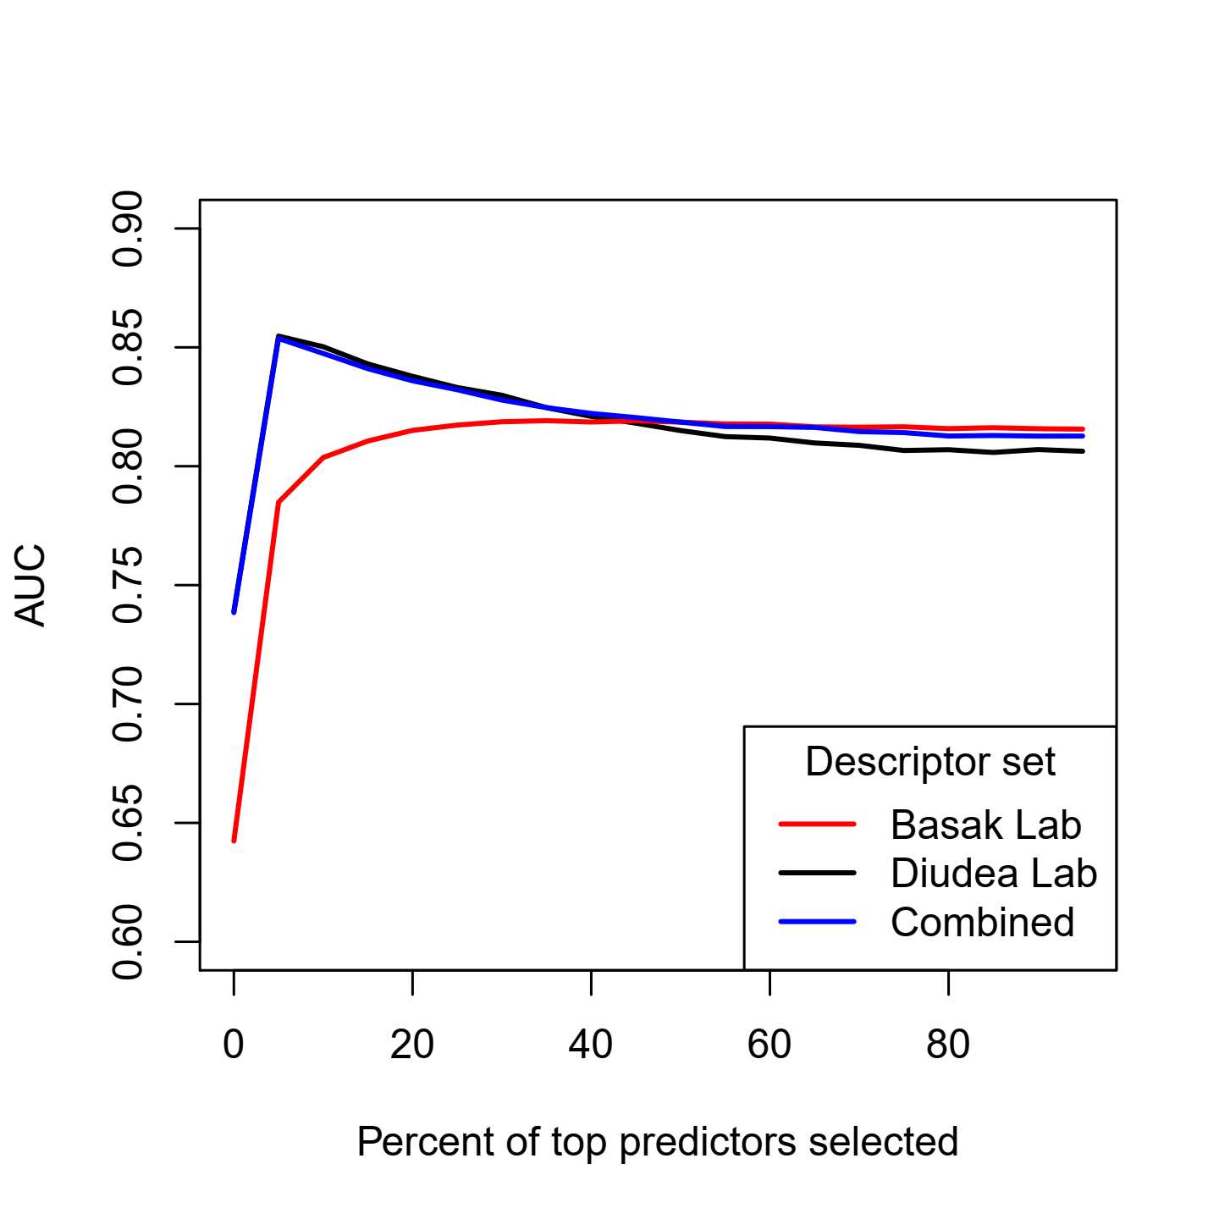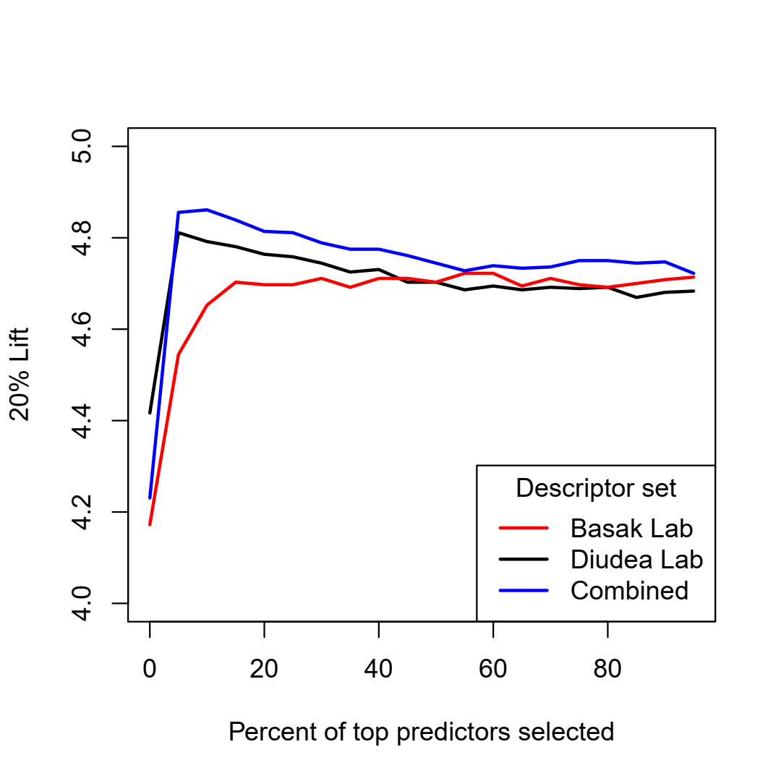

Figure 1: Area Under Curves and 20% Lifts for reduced models with top θ% important descriptors

The two sets of descriptors behave very differently in the prediction curves. For the Diudea set, the top 5% descriptors are extremely predictive, and the variable selection approach actually manages to give a better-performing model than the full model. On the other hand, models corresponding the Basak set of descriptors perform more or less similarly for values of *θ* larger than 25. The combined set of descriptors constantly perform better than both the individual descriptor sets for all values of *θ*. This improvement is slightly better for all values of *θ* when the Diudea set is considered, and for *θ* > 25 when the Basak set is compared with. AUC performance of the Diudea and combined sets are similar across *θ*, while top 20% lifts of the combined set are slightly better.

**5. Discussion**

The main objective of this paper was to use computed molecular descriptors in the prediction of BBB entry of a diverse set of 415 chemicals, and find out influential descriptors with potential mechanistic interpretations. To this end we used two sets of molecular descriptors, viz., set 1 of 198 descriptors calculated by POLLY and Triplet software routinely used by the Basak group at the University of Minnesota, and set 2 of 579 indices calculated by Diudea’s group using TopoCluj and Schrodinger software. Results of AUC and lift analyses in Table 3 show that the two sets of descriptors give similar results, 0.813 and 0.818, respectively, for set 1 and 2. When the combined set of 777 descriptors the AUC was 0.82 which indicates that the increase in the number of descriptors did not make any significant improvement in model quality. The strong mutual intercorrelation of many descriptors that is common in QSAR problems (refs) may explain such results.

If we look at the most influential 10 descriptors (Table 2), the indices selected from the 198 POLLY and Triplet descriptor set are the information theoretic indices and triplet descriptors [30]. The former group quantify neighborhood complexity of atomic neighborhoods in the molecule, while the triplet indices characterize the heterogeneity of atoms in the molecular graph. It is noteworthy that in previous research, principal component analysis (PCA) for a diverse collection of 3,692 chemicals showed that the information theoretic indices are strongly correlated with a distinct principal component (PC) indicating that such indices quantify some aspects of molecular structure not represented by other indices [31].

For the models developed from the set 2 of 578 descriptors calculated by TopoCluj and Schrodinger, PSA, sum of topological distances between O..O, E state topological parameter, ALOGP , and topological charge index of order 5 emerge as important variables. Others have found that hydrophobicity descriptors like CLogP value is important for BBB prediction [32]. PSA may be related to the extent of molecular polarity which is related to the hydrophobicity of the chemical. E state topological parameter and topological charge index quality the electronic nature of the solute.

In conclusion, the two sets of descriptors of 198 and 579 calculated for the set of 415 BBB data led to the development of good quality predictive models. The individual sets were independently as good as one another in the formulation of QSARs for the BBB data. Further studies with other data sets are needed to understand the utility of these mathematical molecular descriptors in assessing the blood-brain entry of chemicals.

**Conflict of Interest**

We confirm that there is no conflict of interest on the content of this paper.

**Supplementary material**

Supplementary file S1 contain all datasets used in our analysis. Files S2 and S3 contain information on the set of descriptors calculated by the Diudea lab. All code and outputs of the paper are available in x.

**Acknowledgements**

# The authors would like to dedicate this paper to Professor Paola Gramatica for her valuable contributions to the field of QSAR. The research of SM is supported by Prof. George Michailidis during his time at University of Florida Informatics Institute.

# **References**

|  |  |
| --- | --- |
| [1] | T. Hou, J. Wang, W. Zhang and a. others, "Recent Advances in Computational Prediction of Drug Absorption and Permeability in Drug Discovery," *Curr. Med. Chem.,* vol. 13, pp. 2653-2667, 2006. |
| [2] | M. Hammarlund-Udenaes, M. Fridén, S. S. and A. Gupta, "On the rate and extent of drug delivery to the brain," *Pharm Res.,* vol. 25, p. 1737, 2008. |
| [3] | X. Liu, C. Chen and B. J. Smith, "Progress in Brain Penetration Evaluation in Drug Discovery and Development," *J. Pharmacol. Exp. Ther.,* vol. 325, pp. 349-356, 2008. |
| [4] | A. R. Mehdipour and M. Hamidi, "Brain drug targeting: a computational approach for overcoming blood-brain barrier," *Drug Discov. Today,* vol. 14, pp. 1030-1036, 2009. |
| [5] | R. Cecchelli, V. Berezowski, S. Lundquist and a. others, "Modelling of the blood-brain barrier in drug discovery and development," *Nat. Rev. Drug Discov.,* vol. 6, no. 8, pp. 650-661, 2007. |
| [6] | S. Aday, R. Cecchelli, D. Hallier-Vanuxeem and a. others, "Stem Cell-Based Human Blood-Brain Barrier Models for Drug Discovery and Delivery," *Trends Biotechnol.,* vol. 34, no. 5, pp. 382-393, 2016. |
| [7] | H. Li, C. W. Yap, C. Y. Ung and others, "Effect of Selection of Molecular Descriptors on the Prediction of Blood-Brain Barrier Penetrating and Nonpenetrating Agents by Statistical Learning Methods," *J. Chem. Inf. Model.,* vol. 45, pp. 1376-1384, 2005. |
| [8] | S. Majumdar, S. C. Basak, C. N. Lungu, M. V. Diudea and G. D. Grunwald, "Mathematical structural descriptors and mutagenicity assessment: a study with congeneric and diverse datasets," *SAR QSAR Environ. Res.,* vol. 2018, pp. 579-590, 2018. |
| [9] | O. T. Devinyak and R. B. Lesyk, "5-Year Trends in QSAR and its Machine Learning Methods," *Curr. Comput. Aided Drug Des.,* vol. 12, no. 4, pp. 265-271, 2016. |
| [10] | I. Guyon, J. Weston, S. Barnhill and V. Vapnik, "Gene selection for cancer classification using support vector machines," *Mach. Learning,* vol. 46, pp. 389-422, 2002. |
| [11] | Small-Molecule Drug Discovery Suite 2009, New York, NY: Schrödinger, LLC, 2009. |
| [12] | O. Ursu and M. V. Diudea, TOPOCLUJ software program, Cluj, Romania: Babes-Bolyai University, 2005. |
| [13] | S. C. Basak, B. D. Gute and G. D. Grunwald, "A hierarchical approach to the development of QSAR models using topological, geometrical and quantum chemical parameters," in *Topological Indices and Related Descriptors in QSAR and QSPR*, J. Devillers and A. T. Balaban, Eds., Amsterdam, The Netherlands, Gordon and Breach Science Publishers, 1999, pp. 675-696. |
| [14] | S. C. Basak, D. Mills, B. D. Gute and D. M. Hawkins, "Predicting Mutagenicity of Congeneric and Diverse Sets of Chemicals Using Computed Molecular Descriptors: A Hierarchical Approach," in *Quantitative structure-activity relationship (QSAR) models of mutagens and carcinogens*, R. Benigni, Ed., Boca Raton, FL, CRC Press, 2007, pp. 215-242. |
| [15] | S. C. Basak, R. Natarajan, D. Mills, D. M. Hawkins and J. J. Kraker, "Quantitative structure-activity relationship modeling of juvenile hormone mimetic compounds for Culex pipiens larvae, with a discussion of descriptor-thinning methods," *J. Chem. Inf. Model.,* vol. 46, pp. 65-77, 2006. |
| [16] | S. Majumdar, S. C. Basak and G. D. Grunwald, "Adapting interrelated two-way clustering method for quantitative structure-activity relationship (QSAR) modeling of mutagenicity/non-mutagenicity of a diverse set of chemicals," *Curr. Comput. Aided Drug Des.,* vol. 9, pp. 463-471, 2013. |
| [17] | S. C. Basak, D. K. Harriss and V. R. Magnuson, "POLLY v2.3," Copyright of the University of Minnesota, 1988. |
| [18] | S. Basak, G. Grunwald and A. Balaban, "TRIPLET," Copyright of the Regents of the University of Minnesota, 1993. |
| [19] | L. Breiman, "Random Forests," *Mach. Learning,* vol. 45, no. 1, pp. 5-32, 2001. |
| [20] | S. Kortagere, D. Chekmarev, W. J. Welsh and S. Ekins, "New predictive models for blood-brain barrier permeability of drug-like molecules," *Pharm. Res.,* vol. 25, no. 8, pp. 1836-1845, 2008. |
| [21] | D. Hawkins, S. Basak and D. Mills, "Assessing model fit by cross-validation," *J. Che. Inf. Comput. Sci.,* vol. 3, pp. 579-586, 2003. |
| [22] | S. Majumdar and S. C. Basak, "Beware of external validation! – A Comparative Study of Several Validation Techniques used in QSAR Modelling," *Curr. Comput. Aided Drug Des.,* vol. 14, p. in press, 2018. |
| [23] | A. M. Molinro, R. Simon and R. M. Pfeiffer, "Prediction error estimation: a comparison of resampling methods," *Bioinformatics,* vol. 21, no. 15, pp. 3301-307, 2005. |
| [24] | A. Golbraikh and A. Tropsha, "Beware of q2!," *J. Mol. Graphics Model.,* vol. 20, pp. 269-276, 2002. |
| [25] | Q.-S. Xu and Y.-Z. Liang, "Monte Carlo cross validation," *Chemom. Intell. Lab. Syst.,* vol. 56, pp. 1-11, 2001. |
| [26] | D. Hawkins, S. Basak and D. Mills, "QSARs for chemical mutagens from structure: ridge regression fitting and diagnostics," *Environ. Toxicol. Pharmacol.,* vol. 16, pp. 37-44, 2004. |
| [27] | S. Majumdar and S. C. Basak, "Exploring intrinsic dimensionality of chemical spaces for robust QSAR model development: A comparison of several statistical approaches," *Curr. Comput. Aided Drug Des.,* vol. 12, no. 4, pp. 294-301, 2016. |
| [28] | S. C. Basak and S. Majumdar, "Current landscape of hierarchical QSAR modeling and its applications: Some comments on the importance of mathematical descriptors as well as rigorous statistical methods of model building and validation: Volume 1," in *Advances in Mathematical Chemistry and Applications*, Bentham e-Books, 2016, pp. 251-281. |
| [29] | R Core Team, *R: A Language and Environment for Statistical Computing version 3.1.1,* 2014. |
| [30] | S. C. Basak, "Use of molecular complexity indices in predictive pharmacology and toxicology: A QSAR approach," *Med. Sci. Res.,* vol. 15, pp. 605-609, 1987. |
| [31] | S. C. Basak, V. R. Magnusson, G. J. Niemi and R. R. Regal, "Determining structural similarity of chemicals using graph-theoretic indices," *Discrete Appl. Math.,* vol. 19, pp. 17-44, 1988. |
| [32] | M. Iyer, R. Mishru, Y. Han and A. J. Hopfinger, "Predicting blood-brain barrier partitioning of organic molecules using membrane-interaction QSAR analysis," *Pharm. Res.,* vol. 19, no. 11, pp. 1611-1621, 2002. |
| [33] | C. Lungu, M. Diudea, M. Putz and I. Grudziński, "Linear and Branched PEIs (Polyethylenimines) and Their Property Space," *Int. J. Mol. Sci.,* vol. 17, p. 555, 2016. |
| [34] | C. Lungu, S. Ersali, B. Szefler, A. Pirvan-Moldovan, S. C. Basak and M. V. Diudea, "Dimensionality of big data set explored by cluj descriptors," *Studia UBB Chemia,* vol. LXII, no. 3, pp. 197-204, 2017. |
| [35] | S. C. Basak and S. Majumdar, "Editorial: The Importance of Rigorous Statistical Practice in the Current Landscape of QSAR Modelling," *Curr. Comput. Aided Drug Des.,* vol. 11, no. 1, pp. 2-4, 2015. |